Health For All
Health for all is a med-help app with the central idea of facilitating especially the doctors to get the case history of the patient along with the test reports and medications prescribed. This can be a great aid in determining the future course of medications. The app contains one account for patient, one for doctor and on for hospital. For every doctor and hospital a corresponding profile containing the designations and visiting hours of the doctors are made available. The core idea is to provide a unique identity to each patient like a birth certificate so that every small ailment is accurately recorded and taken care of.

Proposed Advantages:
- Can be a great alternative to present manual case keeping strategies. Also, since everything can be fed, the patient is saved the trouble of searching through all previous documents like reports and case papers.
- This can be great way to preserve the case histories of thousands of people.
- The app contains a feature of referring to doctor for major ailments. In future, it can be used to send email notifications to doctors about who is referred to by which doctor at what hospital.
- Can be used to monitor vaccinations for infants. Can also be used by paediatricians to predict which medicines would produce best results assessing the previous medications.
- Since all hospitals are enrolled along with the doctors, we can introduce more transparency and speed in tackling the issues of the health department.
- Uses simple mySQL database to store data. Hence, data fetching is quicker.

Future Scope
- All government, trust and private hospitals can have accounts , thereby quickly searching the nearby hospitals.
- SMS system can be introduced for vaccination systems.
- Can be made into a full fledged case keeping method.
- Can be extended to preserve details like eMamta profile for ladies, children healthcare programs.

The app:

Health for all is a UI oriented app where all
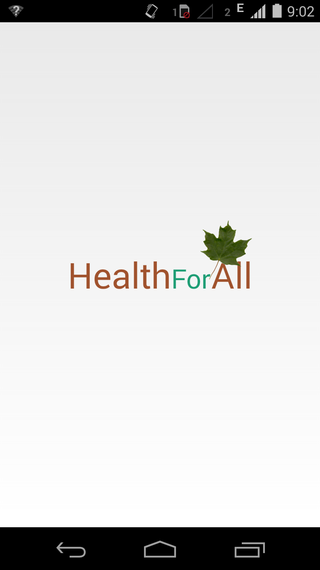
details are fetched from the remote server. The app
currently functions on localhost and ip address
192.168.43.9 . The app runs on a local machine with
wamp server. The database can be efficiently
translated to a new domain, requiring minimal
changes in the app. The app runs on android
platforms 2.3 to the latest. The app has been tested
and verified to be working for the mentioned
platforms. On the server side, simple PHP scripts
provide communication link between the android
and database architecture. The app contains a root
account capable of adding doctor and hospital
accounts while the hospital can directly add patient
and cases. Internet/ Wi-fi connectivity is essential
for the app to function since the app store minimal
login details in android and thereby is extremely
compact with space requirement < 1.5MB.

Present State:
Since, the app works on only local machine, data may not be available without the server being on.

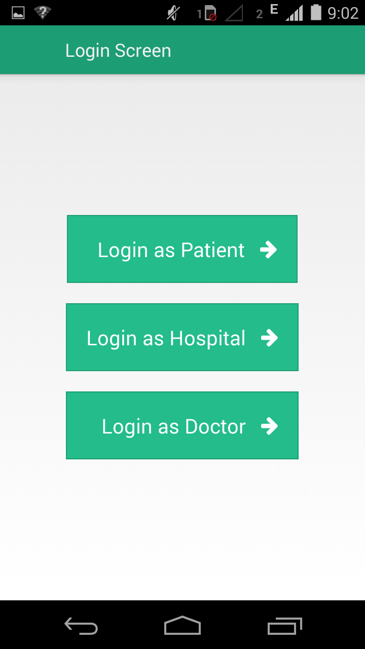
Features:

1.)Login: Can login through any option of the three.

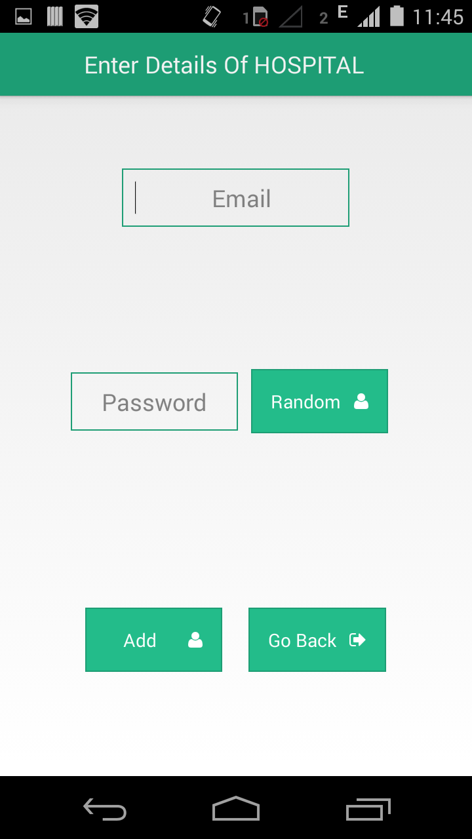
2.) Adding hospital and doctor accounts.
To root user can add doctor and hospital accounts while generating random passwords. These can be communicated via mail or SMS to the corresponding hospital or doctor.

3.) The Home Button
The home button opens up a drawer containing options for logging out, editing profile and resetting the password. For hospitals, all talukas, districts and other details are contained in the online database.

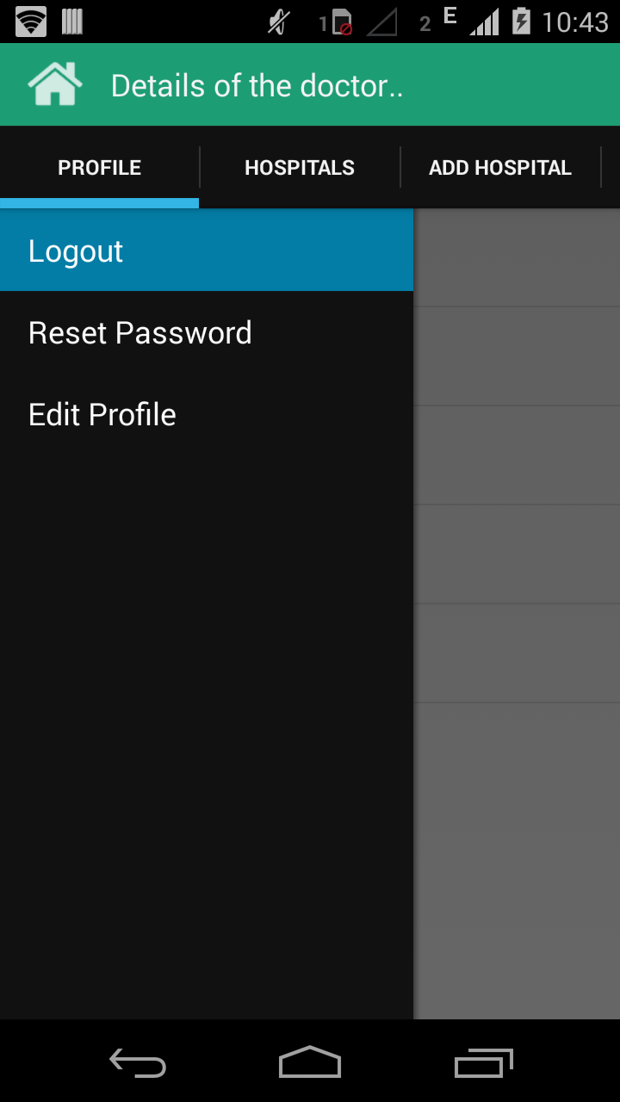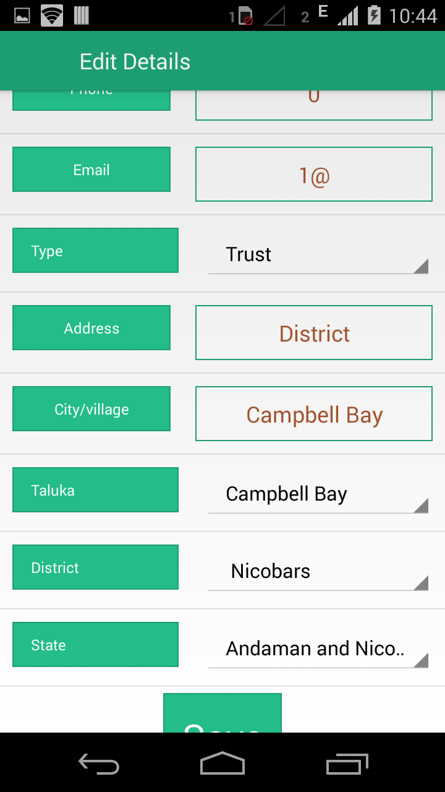

4.) The profile view
The profile contains all the details regarding the patient/doctor/hospital.

a.) For the patient it also contains the case histories of all the corresponding patient sorted according to newest on the top.
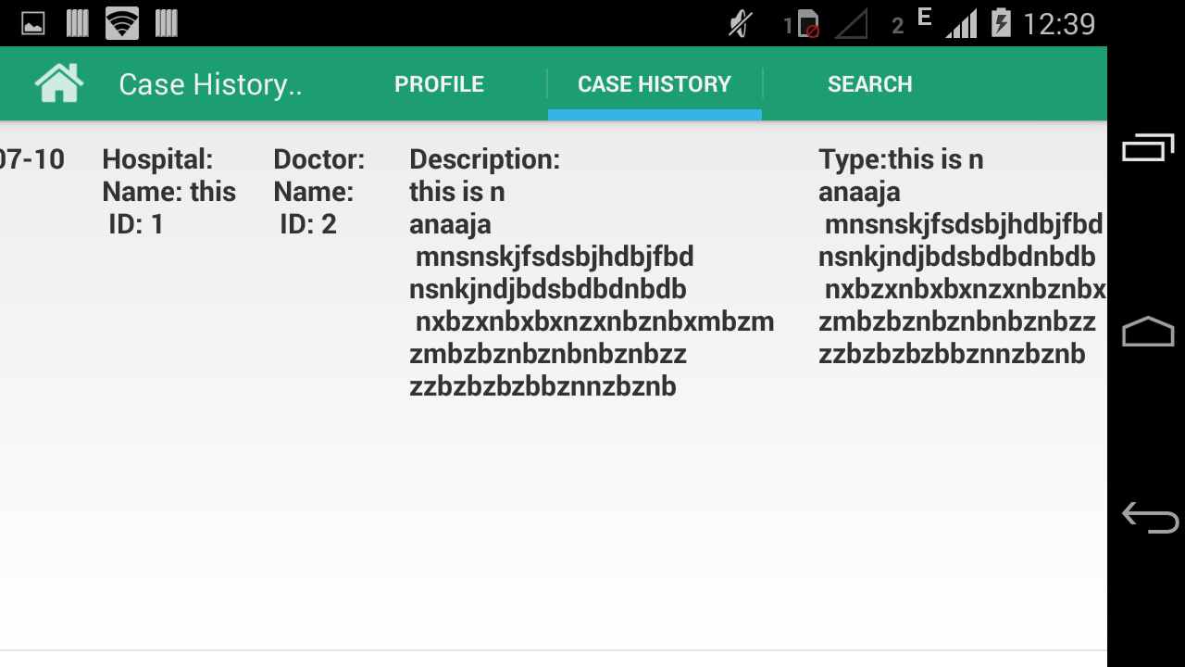
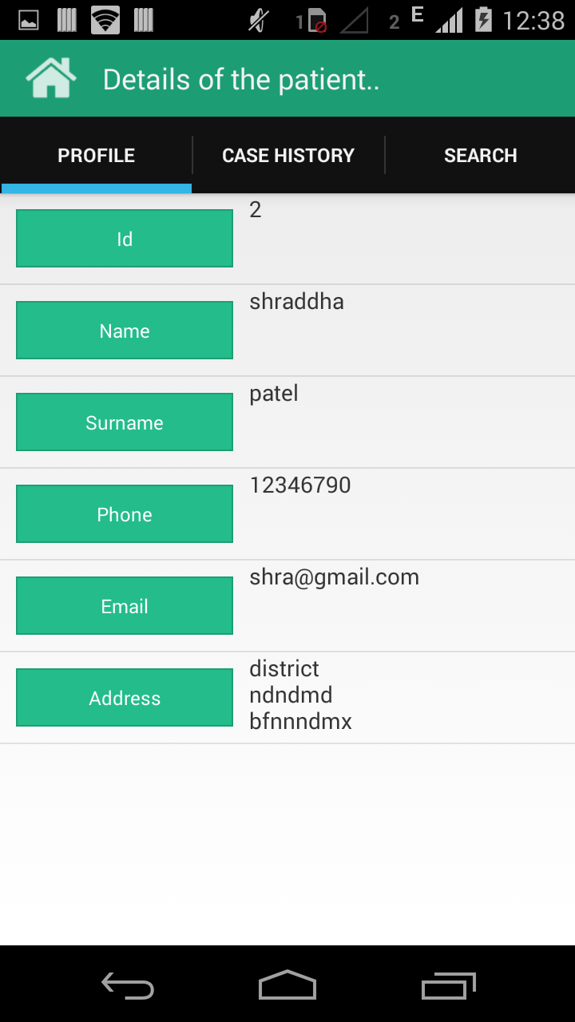

b.) For hospitals, it contains interface to add patient and case. It also contains the details of all the doctors working in the hospital and their designation.

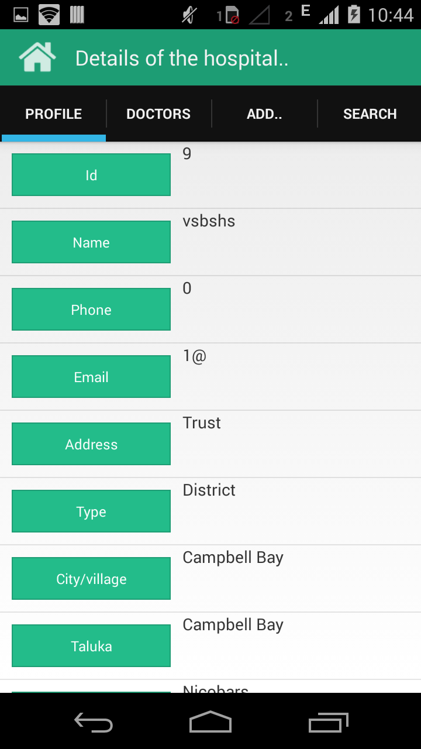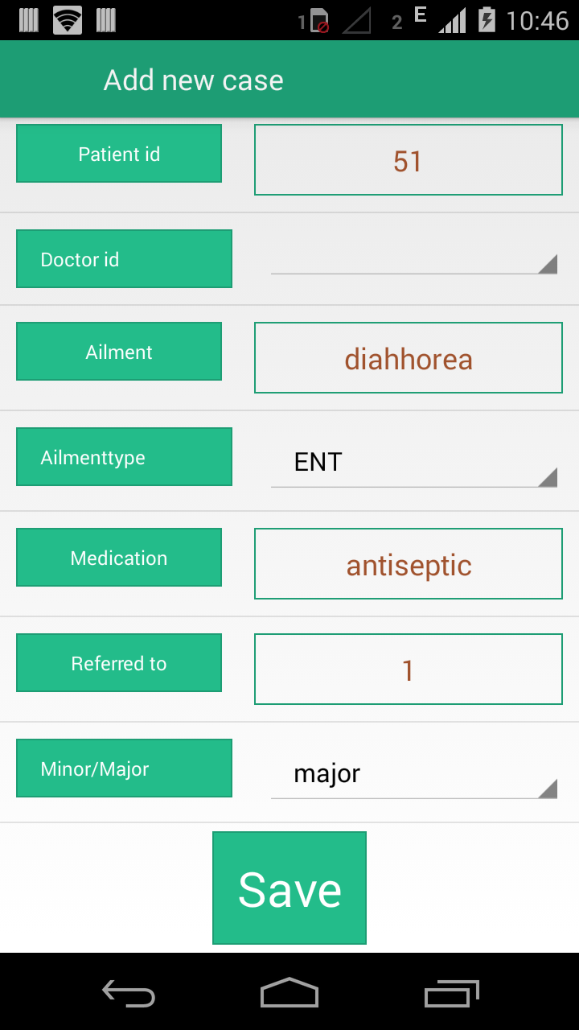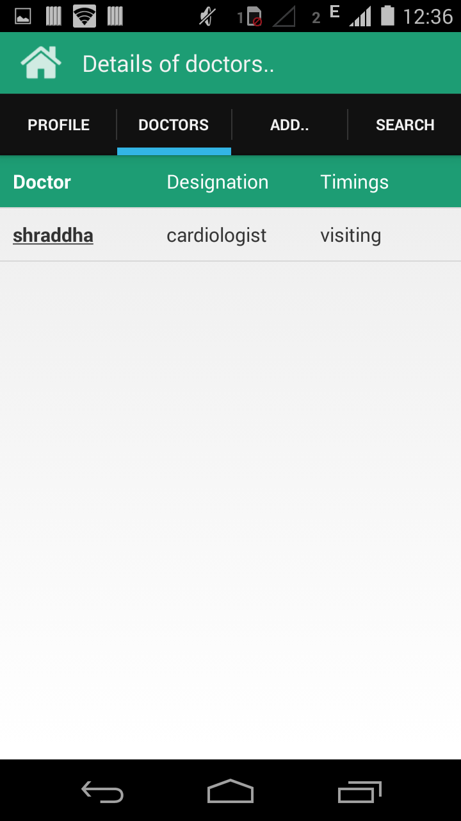

c.)For doctors, an interface to add the hospitals to his profile is added. Also, all the hospitals he/she is currently working in is also mentioned.

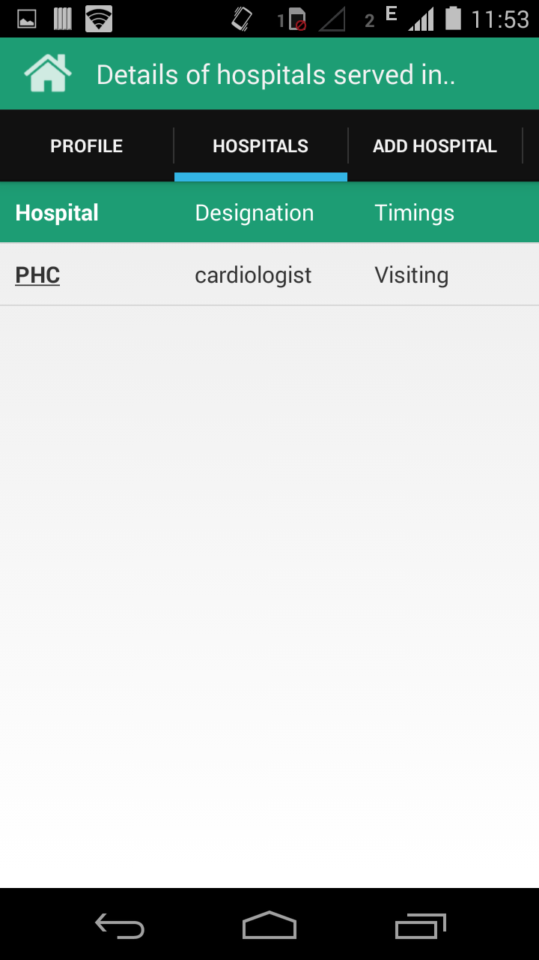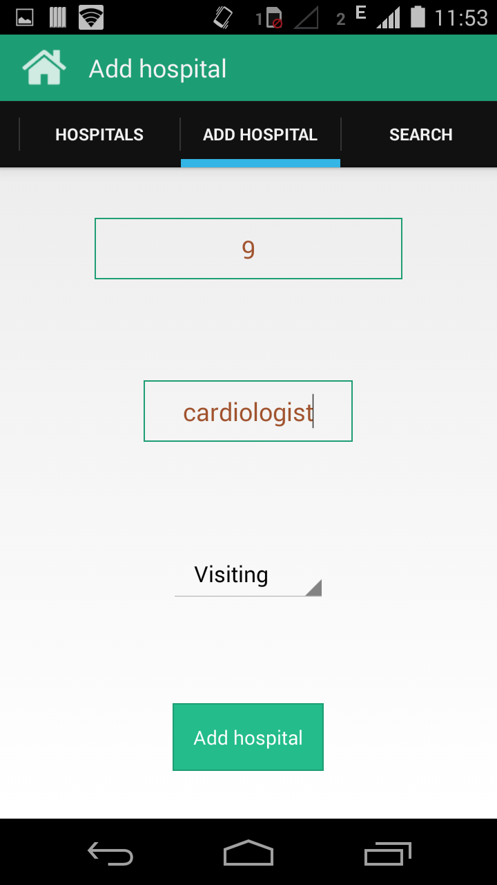

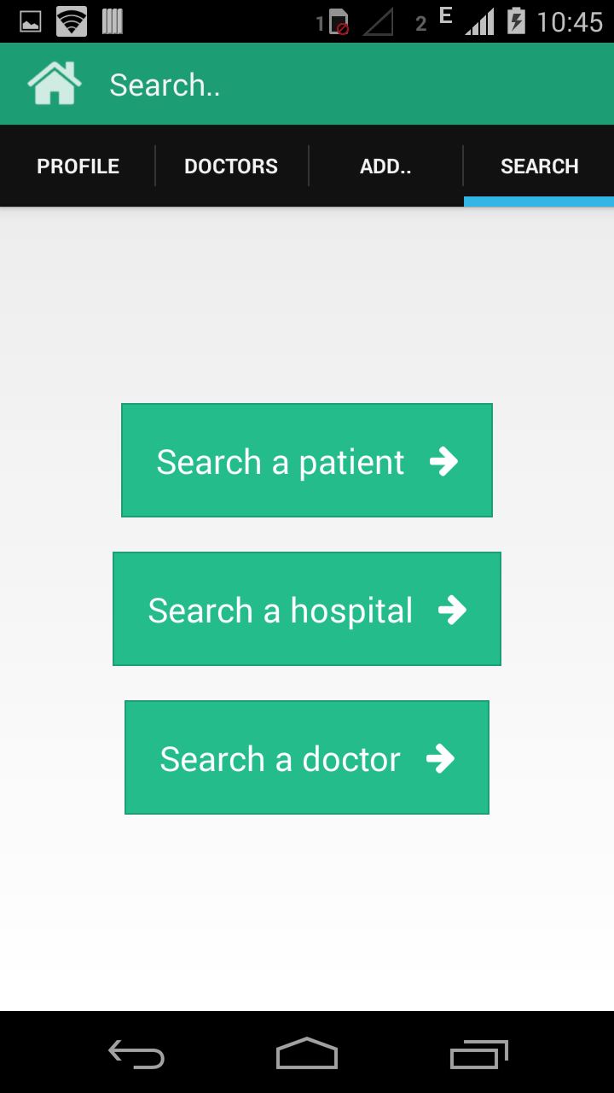
5.) Search View
The hospital and doctor can search any hospital, patient or doctor by their email id or unique ids. The liberty of searching any fellow patient is not made available to any patient.

